CSC ­­­1310 PROGRAM 4

Spring 2021

Depth First Search of a Graph

# Description

This program works with graphs like the one in Graph Diagram #1 below.

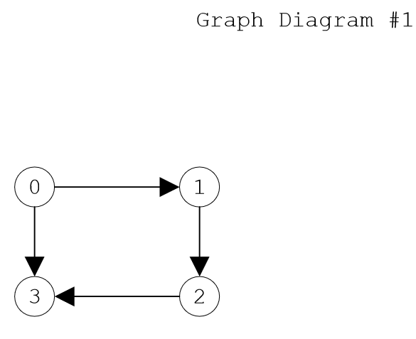

Graph Diagram #

Write a C++ program that asks the user for the name of a file that contains a digraph’s vertices and edges. Your program should read a digraph’s vertices and the edges from the given text file (example below).

**graph1.txt text:**

4

0 1

1 2

2 3

0 3

Then, your program should create an adjacency matrix and print the adjacency matrix.

Adjacency Matrix:

0 1 0 1

0 0 1 0

0 0 0 1

0 0 0 0

Then, your program should create an adjacency list and print the adjacency list.

Adjacency List...

0--->1--->3--->NULL

1--->2--->NULL

2--->3--->NULL

3--->NULL

Then, your program should print out the order the vertices are traversed using the depth-first search (DFS) algorithm.

Now traversing & printing graph vertices with DFS.

0 1 2 3

Then, the program should end.

# files given & Assumptions you can make

* You are provided with the Stack class.
* You may assume that all digraphs have only integer vertices.
* You may assume that all digraphs contain at least two vertices, zero and one.
* No integers are skipped. For example, a digraph with 7 vertices contains vertices 0, 1, 2, 3, 4, 5, & 6.
* You are given the text files which your program will be tested with: graph_1.txt, graph_2.txt, graph_3.txt, graph_4.txt, and graph_5.txt

# What To Turn In

Zip **ALL** the files necessary to run your program **(listed below)** and then upload it to the program 4 assignment folder in ilearn by the due date.

* graph.cpp (source file containing main function)
* GraphMatrix.h (header file containing class that will create the adjacency matrix)
* GraphList.h (header file containing class that will create the adjacency list)
* Stack.h (given)
* graph_1.txt (given)
* graph_2.txt (given)
* graph_3.txt (given)
* graph_4.txt (given)
* graph_5.txt (given)

# Graph.cpp

This file contains the main function. It should include the other header files that you will use in your program.

**Here is the order of how your main function should go:**

* Ask the user for the filename of the file that contains the graph information (example: graph_1.txt).
* Read in the number of vertices from the file and store in a variable. You will use this variable to create your matrix object and then your list object.
* Read each pair of vertices from the file that makes each edge and then add that edge to the matrix. Then add that edge to the adjacency list as well.
* Print the adjacency matrix.
* Print the adjacency list.
* Create a stack object to use in the DFS algorithm.
* You may also want to dynamically create a Boolean array (I called mine visited) which is the size of the number of vertices to keep track of which vertices have been visited.
* Use the stack to implement the Depth-First-Search algorithm. Your solution may either be recursive, or not.
* Print out the vertex when you push it to the stack (meaning it has been visited).

# GRAPHMATRIX.h

## Private attributes:

* int ** vertexMatrix – this is going to be a 2D array of integers (the matrix), which will be dynamically allocated in the constructor.
* int numVertices
* int numEdges

## Public Member Functions:

* **constructor** – accepts an integer (the number of vertices in the graph), sets the private attribute numVertices, dynamically allocates a 2D array, sets all elements of the 2D array to zero
* **destructor** – deletes 2D array
* **addEdge** – accepts two vertices – sets the 2D array to 1 (instead of zero) at that element in the matrix
* **printGraph** – prints the matrix
* **isThereAnEdge** – this will accept a row & column index and will return true if the matrix element is equal to 1 (there is an edge) or false otherwise.

# GRAPHlist.h

## Private attributes:

* ListNode structure (containing integer value & pointer to next ListNode
* ListNode ** headArray; (array of linked lists)
* int numVertices
* int numEdges

## Public Member Functions:

* **constructor** – accepts an integer (the number of vertices in the graph), sets the private attribute numVertices, dynamically allocates an array of pointers to ListNodes
* **destructor** – deletes linked lists
* **addEdge** – accepts two vertices – create the node & add it to appropriate linked list
* **printGraph** – prints the list

# Extra Credit Opportunity (10 points)

## (5 points) STARTING VERTEX

Instead of always starting with zero vertex, determine which vertex to start with so that all nodes are included.

In order to get full credit, you must create a function in the Adjacency Matrix class called getFirstVertex(), which will check to see if there are any columns in the matrix that are all zeros (meaning that no other vertices have an edge that has a directional arrow pointing to this particular vertex in this column). This function should return the integer vertex that should be the starting point for your DFS algorithm. If there are no columns with all zeros, then the function should return zero.

Below is an example of a digraph (Graph Diagram #2) and the resulting adjacency matrix, adjacency list, and DFS traversal list. Notice that the first vertex should be 3 instead of zero if you implemented the getFirstVertex() function correctly.

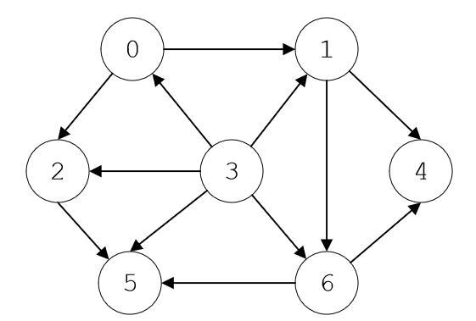

Graph Diagram #

Adjacency Matrix:

0 1 1 0 0 0 0

0 0 0 0 1 0 1

0 0 0 0 0 1 0

1 1 1 0 0 1 1

0 0 0 0 0 0 0

0 0 0 0 0 0 0

0 0 0 0 1 1 0

Now traversing & printing graph vertices with DFS.

3 0 1 4 6 5 2

## (5 points) ACYCLIC GRAPH

Determine & indicate if a graph is acyclic (contains a cycle). **You may only implement the acyclic graph feature if you have already implemented the starting vertex feature.**

Below is an example of a graph (Graph Diagram 3) that is acyclic and how your output should look if you implement this extra credit feature. To test, use the given graph_3.txt or graph_4.txt because they both contain a cycle. The other example graphs do not.

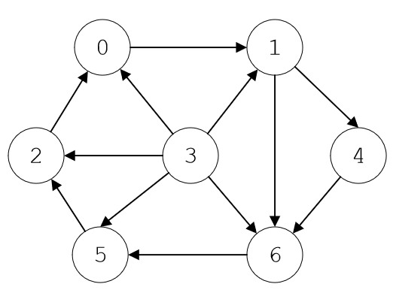

Graph Diagram #

Adjacency Matrix:

0 1 0 0 0 0 0

0 0 0 0 1 0 1

1 0 0 0 0 0 0

1 1 1 0 0 1 1

0 0 0 0 0 0 1

0 0 1 0 0 0 0

0 0 0 0 0 1 0

Adjacency List...

0--->1--->NULL

1--->4--->6--->NULL

2--->0--->NULL

3--->0--->1--->2--->5--->6--->NULL

4--->6--->NULL

5--->2--->NULL

6--->5--->NULL

Now traversing & printing graph vertices with DFS.

3 0 1 4 6 5 2

Ah shooty pooty. This graph has a cycle.

# Graph Text Files

There are five given graph text files. Below is a description of what the numbers mean in the text file for graph_1.txt.

4

0 1

1 2

2 3

0 3

The **4** is how many vertices there are.

The other numbers represent the **edges**. For example, there is an edge from 0 to 1.

# Sample Output without extra credit options

## For graph_1.txt:



Graph Diagram # 1

Enter the name of your file that contains the graph vertices: graph_1.txt

Adjacency Matrix:

0 1 0 1

0 0 1 0

0 0 0 1

0 0 0 0

Adjacency List...

0--->1--->3--->NULL

1--->2--->NULL

2--->3--->NULL

3--->NULL

Now traversing & printing graph vertices with DFS.

0 1 2 3

## For graph_2.txt:



Graph Diagram # 2

Enter the name of your file that contains the graph vertices: graph_2.txt

Adjacency Matrix:

0 1 1 0 0 0 0

0 0 0 0 1 0 1

0 0 0 0 0 1 0

1 1 1 0 0 1 1

0 0 0 0 0 0 0

0 0 0 0 0 0 0

0 0 0 0 1 1 0

Adjacency List...

0--->1--->2--->NULL

1--->4--->6--->NULL

2--->5--->NULL

3--->0--->1--->2--->5--->6--->NULL

4--->NULL

5--->NULL

6--->4--->5--->NULL

Now traversing & printing graph vertices with DFS.

0 1 4 6 5 2

## For graph_3.txt:



Graph Diagram # 3

Enter the name of your file that contains the graph vertices: graph_3.txt

Adjacency Matrix:

0 1 0 0 0 0 0

0 0 0 0 1 0 1

1 0 0 0 0 0 0

1 1 1 0 0 1 1

0 0 0 0 0 0 1

0 0 1 0 0 0 0

0 0 0 0 0 1 0

Adjacency List...

0--->1--->NULL

1--->4--->6--->NULL

2--->0--->NULL

3--->0--->1--->2--->5--->6--->NULL

4--->6--->NULL

5--->2--->NULL

6--->5--->NULL

Now traversing & printing graph vertices with DFS.

0 1 4 6 5 2

## For graph_4.txt:

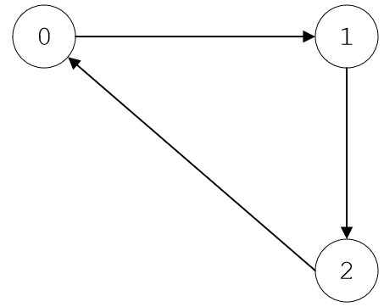

Graph Diagram #

Enter the name of your file that contains the graph vertices: graph_4.txt

Adjacency Matrix:

0 1 0

0 0 1

1 0 0

Adjacency List...

0--->1--->NULL

1--->2--->NULL

2--->0--->NULL

Now traversing & printing graph vertices with DFS.

0 1 2

## For graph_5.txt:

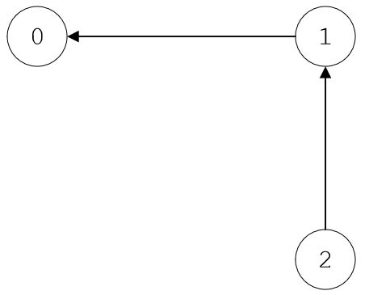

Graph Diagram #

Enter the name of your file that contains the graph vertices: graph_5.txt

Adjacency Matrix:

0 0 0

1 0 0

0 1 0

Adjacency List...

0--->NULL

1--->0--->NULL

2--->1--->NULL

Now traversing & printing graph vertices with DFS.

0

# SAMPLE OUTPUT (WITH EXTRA CREDIT APPLIED)

## For graph_1.txt:

Enter the name of your file that contains the graph vertices: graph_1.txt

Adjacency Matrix:

0 1 0 1

0 0 1 0

0 0 0 1

0 0 0 0

Adjacency List...

0--->1--->3--->NULL

1--->2--->NULL

2--->3--->NULL

3--->NULL

Now traversing & printing graph vertices with DFS.

0 1 2 3

## For graph_2.txt:

Enter the name of your file that contains the graph vertices: graph_2.txt

Adjacency Matrix:

0 1 1 0 0 0 0

0 0 0 0 1 0 1

0 0 0 0 0 1 0

1 1 1 0 0 1 1

0 0 0 0 0 0 0

0 0 0 0 0 0 0

0 0 0 0 1 1 0

Adjacency List...

0--->1--->2--->NULL

1--->4--->6--->NULL

2--->5--->NULL

3--->0--->1--->2--->5--->6--->NULL

4--->NULL

5--->NULL

6--->4--->5--->NULL

Now traversing & printing graph vertices with DFS.

3 0 1 4 6 5 2

## For graph_3.txt:

Enter the name of your file that contains the graph vertices: graph_3.txt

Adjacency Matrix:

0 1 0 0 0 0 0

0 0 0 0 1 0 1

1 0 0 0 0 0 0

1 1 1 0 0 1 1

0 0 0 0 0 0 1

0 0 1 0 0 0 0

0 0 0 0 0 1 0

Adjacency List...

0--->1--->NULL

1--->4--->6--->NULL

2--->0--->NULL

3--->0--->1--->2--->5--->6--->NULL

4--->6--->NULL

5--->2--->NULL

6--->5--->NULL

Now traversing & printing graph vertices with DFS.

3 0 1 4 6 5 2

Ah shooty pooty. This graph has a cycle.

## For graph_4.txt:

Enter the name of your file that contains the graph vertices: graph_4.txt

Adjacency Matrix:

0 1 0

0 0 1

1 0 0

Adjacency List...

0--->1--->NULL

1--->2--->NULL

2--->0--->NULL

Now traversing & printing graph vertices with DFS.

0 1 2

Ah shooty pooty. This graph has a cycle.

## For graph_5.txt:

Enter the name of your file that contains the graph vertices: graph_5.txt

Adjacency Matrix:

0 0 0

1 0 0

0 1 0

Adjacency List...

0--->NULL

1--->0--->NULL

2--->1--->NULL

Now traversing & printing graph vertices with DFS.

2 1 0

**THE END**

